How Food Sensitivities Cause Inflammation

Sensitivities can involve both innate and adaptive immune pathways, multiple triggering mechanisms and multiple classes of white blood cells. Pathogenic reactions ultimately lead to the release of proinflammatory and proalgesic mediators from associated white cells with resulting subclinical and clinical inflammatory effects.

Triggering Mechanisms
- Food antigens
- Food chemicals
  - Haptens
  - Amines
  - Pharmacologic
- Immune Complexes
  - IgG
  - IgM
- Lectins
Cellular Activation
- Lymphocytes
  - Sensitized T-cells
  - T-Cells
  - NK Cells
  - K Cells
- Eosinophils
- Basophils
- Monocytes
- Neutrophils
Mediator Release
- Cytokines
  - Interleukins
  - Chemokines
  - TNFs
  - Interferons
- Leukotrienes
- Histamine
- ECP, MPE, Amines
- Prostaglandins
- Others

Migraine

Depression
ADD/ADHD

Autism Spectrum Disorder
Epilepsy

Urticaria (chronic)
Otitis Media

Fibromyalgia
GERD
Arthritis (Inflammatory)
Asthma

Ulcerative Colitis

Irritable Bowel Syndrome
Crohn's Disease
Atopic Dermatitis
Pathophysiologic Effects
- Inflammation
  - Subclinical
  - Clinical
- Tissue damage
Cyclic Vomiting Syndrome
- Pain receptor activation
Polycystic Ovary Syndrome
- Smooth muscle contraction
- Edema
- Excess mucous
Interstitial Cystitis
- Neurological
- Endocrine
- Increased gut permeability

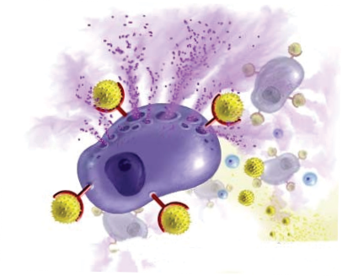
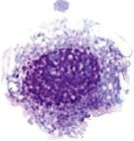
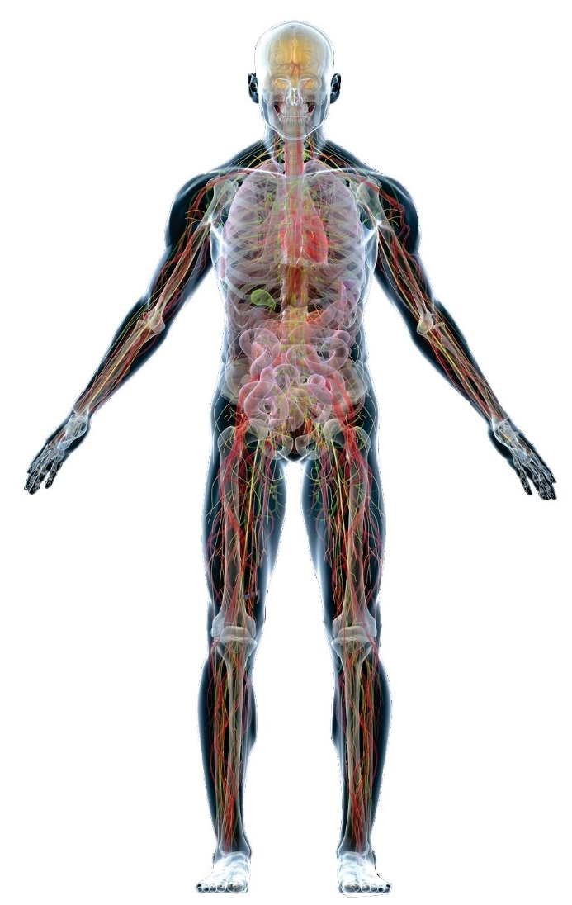

Copyright Oxford Biomedical Technologies, Inc.

